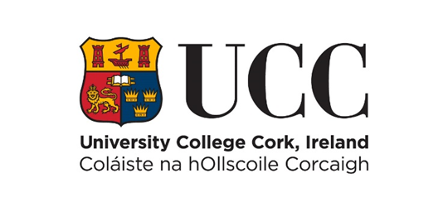

Internal Promotion Process Scheme
Stage 1 - Expression of Interest for Promotion to Senior Lectureship – 2024 Cycles
COVER PAGE – PLEASE READ CAREFULLY
Name: Year of appointment to current post:
School: Discipline:
Please indicate whether part-time or full-time:
Link to your profile (via IRIS or equivalent):
Typed CVs must be submitted online using this template only via e-recruitment using Employee Self Service (ESS) – handwritten forms will not be considered. Please use font type Calibri, Size 11, single spaced, portrait orientation only, on this form.
Before proceeding, please ensure that you have carefully read the Regulation on Academic Promotions to Senior Lectureship. The revised regulation provides for a ‘rolling call’ with two ‘cycles' per year: Cycle A and Cycle B.
Please ensure that the information and summary of achievements listed in each section of this EOI can be supported by indicative evidence if shortlisted to proceed to full application. You must evidence here how you have satisfied the relevant essential criteria requirements as found in Appendix B of the Regulation to establish a prima facie case for promotion. Candidates who establish a prima facie case for promotion will be shortlisted and invited by the Senior Lecturer Promotions Board to make a full application (Stage 2).
The Board reserves the right to verify the information supplied by applicants. Candidates should note that any inaccurate or surplus information will render the application null and void.
Details submitted as part of this promotion process (including for example, any details submitted as part of this Stage 1 application) will be shared with the candidate’s Head of College, candidate’s Head of School, the College Level Board members, Senior Lecturer Promotions Board members, the Human Resources Department and where applicable, if shortlisted, External Reviewers and members of the Appeals Board. Full details of how your personal data is processed by the University are available at https://www.ucc.ie/en/ocla/comp/data/

Please note that it is optional to use a Teaching Profile Summary Template available at: https://www.ucc.ie/en/hr/seniorlectureship/ If using this Template in your application, however, be reminded that you should embed it into your application form within its existing page limits.

NB: This template may not be altered. CVs exceeding the specified page limit will not be considered.

- Learning and Teaching (Font Calibri, size 11, single spaced only)
This should reflect teaching activity and be organised in sections corresponding to the Learning and Teaching criteria detailed in Appendix B. Answers must not exceed the two-page limit.

- Research and Innovation (Font Calibri, size 11, single spaced only)
This should reflect the research approach and profile of the candidate and be organised in sections corresponding to the Research and Innovation criteria detailed in Appendix B. Please list your top 5 publications/outputs on last page of this form. Answers must not exceed the two-page limit.

- Contribution to Academic Citizenship and Engagement (Font Calibri, size 11, single spaced only)
This should be reflective of the level of contribution made by the candidate to academic citizenship and should be organised in sections corresponding to the Contribution to Academic Citizenship and Engagement criteria detailed in Appendix B. Answers must not exceed the one-page limit.

Top Five Research Publications /Outputs
Please provide a list of your top five research publications or other research outputs below. You should not provide links at this stage. Candidates may choose to outline why they chose these publications/ outputs. Answers must not exceed the one-page limit.

